Maths Planning: Week 2 covering the Number 5

Maths | Monday | Tuesday | Wednesday | Thursday | Friday
Register ideas | Counting how many in / not in - clapping 1-10. |  | Number rhymes and chanting |  | Number line / stick counting
Maths lesson Warm up | Song choice / nursery rhymes: 5 little speckled frogs, 5 little ducks, 5 currant buns, 5 little firefighters
Maths lesson Model / Teaching | Show the chidlren a ‘5’ birthday card.  What number does it have on the front? How do you know?  Show the children a birthday cake (dough)  How many candles should we put on the cake?  Lets count them 1:1.  How many altogether?  What other things can we count for the 5th Birthday party.  Show the children a 5 frame.  Why is it called a 5 frame?  Model counting 5 cups onto the frame (1:1 number name for each item).  Encourage the children to join in chorally. Is this 5? How do you know? What numicon piece could we match to this?  Swap 2 of the cups for different variety. Is this still 5? AFL  Give out 5 frames - practise counting 5 using cubes. Does it matter if you have different colours of cube? | PPT: Review our 5 frame counting.  Look at 5 in different variations. Is this 5 or not 5? How do you know? Why not? Prove it using 5 frame.  Today we will use our knowledge of the number 5 to represent this number using pictures.  Roll out wallpaper / large sheets.  Can you draw 5 spots?  Count them to check / count your partners (AFL)  Can you draw around your hand?  Why am I asking you to draw around your hand?  Model labelling each finger/thumb with a number.  Focus on writing each number - teach the number writing rhymes (TWINKL) | PPT: Picture of different numeral representations to promote number talk.  What can you see? Can you spot 5?  Let’s get active!  Listen to me clap [clap 5 times]. How many claps did I do?  Can you clap 5 times?  Vary the speed of claps and the pauses between. Vary the number of claps.  Ask: Is this still 5?  Ask children to perform other physical activities such as hopping, marching, spinning, jumping and waving.  Each action should be performed up to 5 times and with varying speeds and pauses between. | Today we will investigate making 5 on a frame.  Encourage the children to begin subitising (identifying an amount by looking at it, rather than needing to count each item).  Allow them to build the models using 5 multilink cubes.  Show examples of 3, 4 and 5 on a 5 frame - model 5 frame as a fire engine with 5 spaces. Draw children’s attention to the empty cells (seats) in the five frame for 3 and 4 and that for 5 it is full.  Is this 5? Can you check for me?  Children to use own 5 frames to copy. How many more do we need to fill the fire engine?  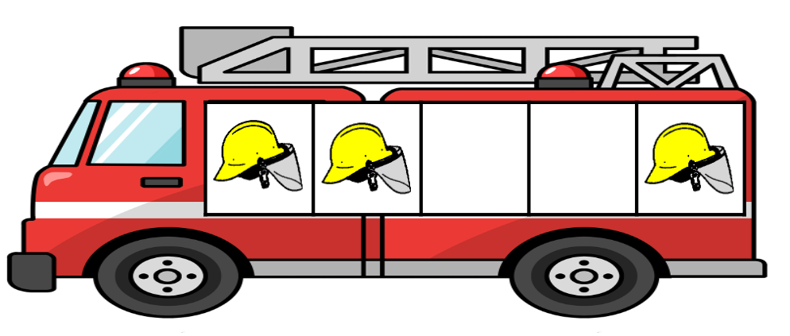  Practise the language needed:  3 add 2 more equals 5.  4 add 1 more equals 5.  Model | Warm up challenge:  Can you order the 5 frames from 1 to 5?  Refer to our 5 board.  Today we will be party planners.  You will have your party planner designer sheet.  What will you have at your 5 birthday party? Gather ideas.  Have pictorial examples of items they could draw…  Balloons, cups, hats, candles, sweets etc.  AFL -who will need support?  Can have pictures already prepped to stick on their party sheet. Can use a 5 frame to count their items onto first and then onto their party planner sheet.
Investigate  During lesson or  *Starter Activity* for provision | Starter activity: 5 birthday party.  We need to find out if we have enough items to match 5.  Use 5 frames to count. Which items do we not have 5 of? How many more do we need?  AFL - who needs counting practise to 5 / counting practise. | Draw your own set of 5 pictures.  Can you label each item with the numbers 1-5?  **Continue starter activity if needed / still popular. | Number 5 Bootcamp  Use PE action cards and set up around the classroom or outside.  Ideas: jump along 5 hoops, kick a ball against a wall 5 times, tap a drum 5 times, scoop 5 spadefuls, hopscotch to 5 and back. | Starter Activity: Race to 5  We need 5 firefighters to fill the fire engine. Who can fill theirs first?  Rolling dice to fill the engine. | 5 Party planner booklet  - Catalogues, phones, cards, decorations, list writing etc.
Provision Links / questions to think about. | Buckets / pots numbered 1-10: counting items to match that number (Sticks, leaves etc)  Can you spot 5 posters (wanted style)  5 numicon pieces in play dough to make 5 birthday cakes.  5 numicon pieces blu tacked in tray - count conkers etc to fill the holes / place numicon pieces on top.  Home corner set as a birthday party.  Mud kitchen - 5 cakes / mixtures: “I am counting 5 scoops of mud, 5 stones, 5 leaves” etc.  Water tray: set up to act out rhymes: 5 frogs on a log, 5 little ducks, 5 firemen putting out 5 fires.  5 birthday cards: making birthday cards with 5 numeral on the front.

