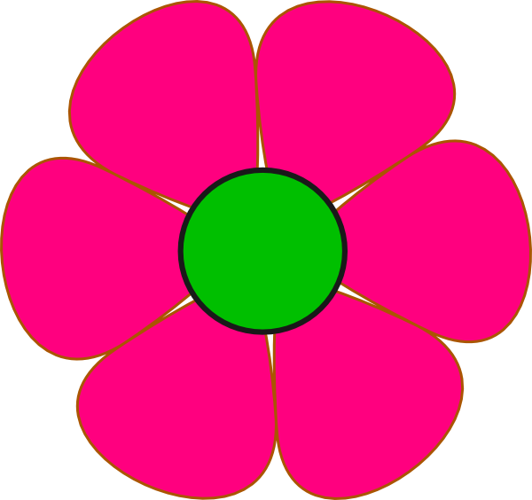

carpet

garden

car

ar

star

far

shark



torch

born

morning

or

horn

forget

fork



shape

lake

a e

tape

name

cake